Project Team
Project Title:
Food Ordering Behaviour and Consumer Trends: A Structured Analysis of Choices and Habits
Team Members:
- Rekha Sri Lakshmipuram – Team Lead
- Charan Sai Vignesh Pusala – Team Member
- Todusu Charita Sree Padmaja – Team Member
- Jajula Gowri Sri – Team Member
- Vannemreddy Keswani – Team Member
Food Ordering Behaviour and Consumer Trends: A Structured Analysis of Choices and Habits
1. INTRODUCTION
The rapid growth of online food delivery platforms has transformed the way consumers order and consume food. With increasing urbanization, busy lifestyles, and advancements in digital technology, food delivery services have become an essential part of modern life. Every day, food delivery platforms generate large volumes of data related to customer preferences, ordering patterns, restaurant performance, delivery times, and spending habits. Analyzing this data can provide valuable insights into consumer behavior and business trends.
The project "Food Ordering Behaviour and Consumer Trends: A Structured Analysis of Choices and Habits" aims to study and analyze food ordering patterns using data analytics and visualization techniques. The project focuses on understanding customer preferences, popular cuisines, ordering frequency, spending behavior, peak ordering periods, and factors influencing consumer decisions.
The dataset used in this project undergoes preprocessing and cleaning to remove inconsistencies and prepare it for analysis. Various analytical techniques are applied to identify trends and relationships among different variables. Interactive visualizations and dashboards are created using Tableau to present meaningful insights in an understandable format.
A Flask-based web application named FoodPulse is developed to integrate and display Tableau dashboards and stories through an easy-to-use interface. The application allows users to navigate through different analytical dashboards and explore consumer trends interactively.
The project is deployed on the cloud using Render, making it accessible through a web browser from any location. The deployment ensures scalability, accessibility, and real-time availability of analytical insights.
The developed system provides several benefits to businesses, restaurant owners, food delivery companies, and researchers by helping them understand customer behavior, improve marketing strategies, optimize operations, and make data-driven decisions.

2. IDEATION PHASE
Problem Statement
Food delivery companies generate huge amounts of customer and transaction data every day. However, extracting useful insights from this data manually is difficult, time-consuming, and inefficient. Businesses require a structured analytical system that can identify customer preferences, trends, and behavioral patterns.
Proposed Solution
Develop a Tableau-based analytics platform integrated with a Flask web application that provides interactive dashboards and visualizations for analyzing food ordering behavior and consumer trends.
Objectives
- Analyze customer food ordering behavior.
- Identify popular cuisines and food categories.
- Study consumer spending habits.
- Analyze peak ordering periods and seasonal trends.
- Provide interactive dashboards for business decision-making.
- Deploy the solution as a web application.
Real-Time Scenarios
Scenario 1: Restaurant Business Planning
Restaurant owners can identify the most popular food items and customer preferences to optimize their menu offerings.
Scenario 2: Marketing Strategy Development
Food delivery companies can use customer behavior insights to design targeted promotional campaigns.
Scenario 3: Demand Forecasting
Businesses can analyze peak ordering hours and trends to improve resource allocation and delivery management.
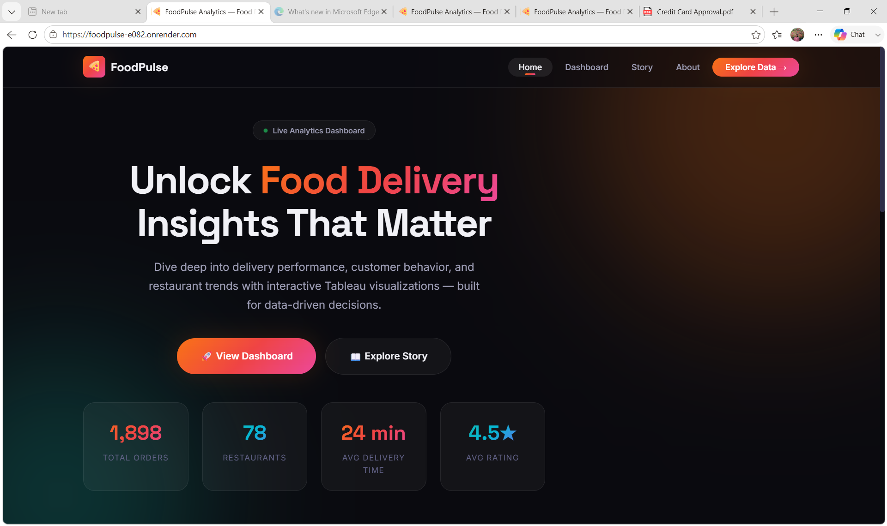3. REQUIREMENT ANALYSIS
Functional Requirements
- User-friendly web interface for dashboard navigation.
- Integration of Tableau dashboards and stories.
- Interactive visualization of food ordering trends.
- Analysis of customer preferences and purchasing behavior.
- Display of restaurant performance metrics.
- Navigation between dashboards, stories, and reports.
- Flask backend integration for web application functionality.
- Cloud deployment support using Render.
Non-Functional Requirements
- Fast dashboard loading time.
- High availability and reliability.
- Easy maintenance and scalability.
- Secure access to analytical reports.
- Responsive design for multiple devices.
- Efficient handling of user requests.
Hardware Requirements
- Processor: Intel Core i3 or above
- RAM: 4 GB minimum
- Storage: 20 GB free space
- Internet Connection
- Windows/Linux Operating System
Software Requirements
- Python 3.x
- Flask
- Tableau Desktop
- Tableau Public/Tableau Server
- HTML
- CSS
- Bootstrap
- Render Cloud Platform
- PyCharm or Visual Studio Code
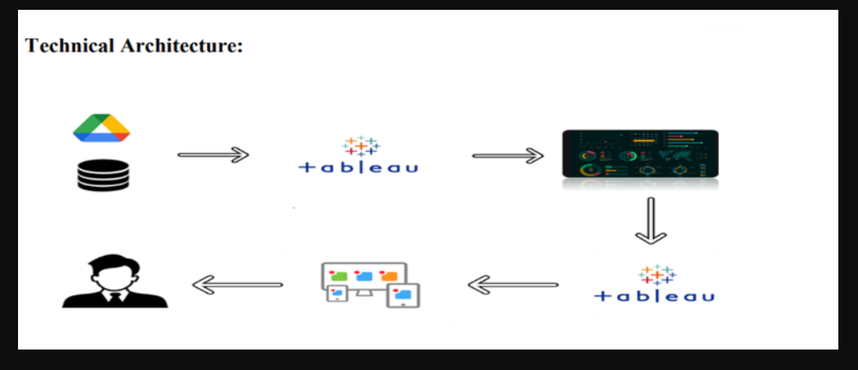

4. PROJECT DESIGN
System Architecture
The Food Ordering Behaviour and Consumer Trends system follows a layered architecture consisting of the User Layer, Presentation Layer, Application Layer, Visualization Layer, Data Layer, and Deployment Layer.
The workflow begins with collecting food ordering data from the FoodHub dataset. The data is cleaned and transformed to ensure consistency and accuracy. Various analytical techniques are then applied to identify consumer trends and behavioral patterns.
Interactive dashboards and stories are developed using Tableau to visualize important business insights such as:
- Customer ordering preferences
- Popular cuisines
- Peak ordering periods
- Restaurant performance
- Consumer spending patterns
- Delivery trends
The Tableau visualizations are integrated into a Flask web application called FoodPulse, allowing users to access all analytical reports through a centralized web interface.
Finally, the application is deployed on Render cloud hosting, making it accessible through the internet.

Project Modules
Module 1: Data Collection
The project begins with collecting food ordering data containing customer information, restaurant details, cuisines, order values, ratings, and delivery information.
Module 2: Data Cleaning and Preparation
The collected dataset is cleaned by removing duplicate entries, handling missing values, and standardizing data formats to improve analysis quality.
Module 3: Exploratory Data Analysis
EDA techniques are applied to understand customer behavior and identify hidden patterns in food ordering habits.
Module 4: Tableau Dashboard Development
Interactive dashboards are developed to visualize:
- Popular cuisines
- Order frequency
- Customer spending
- Restaurant performance
- Delivery patterns
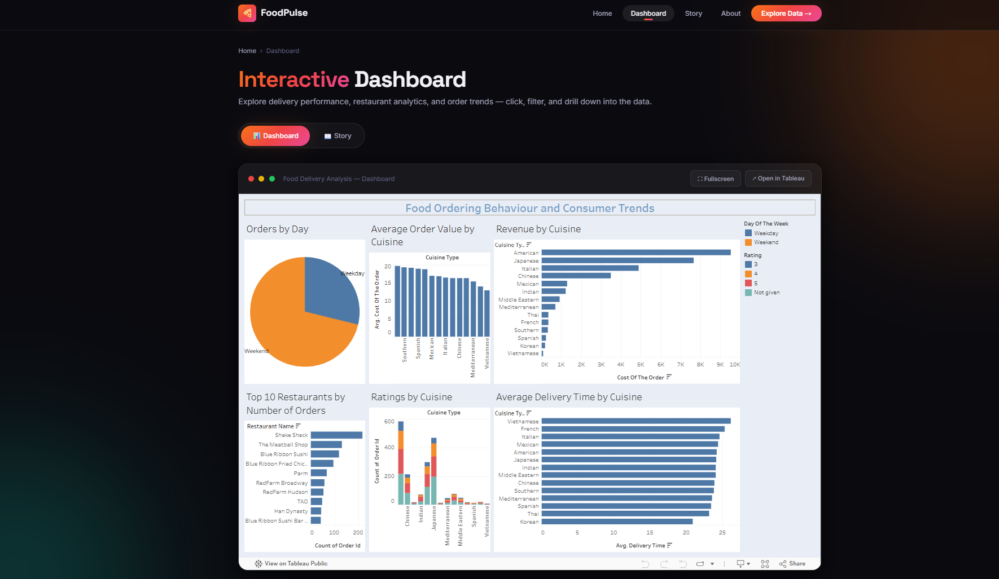
Module 5: Tableau Story Development
Tableau stories are created to provide a sequential explanation of consumer trends and business insights.
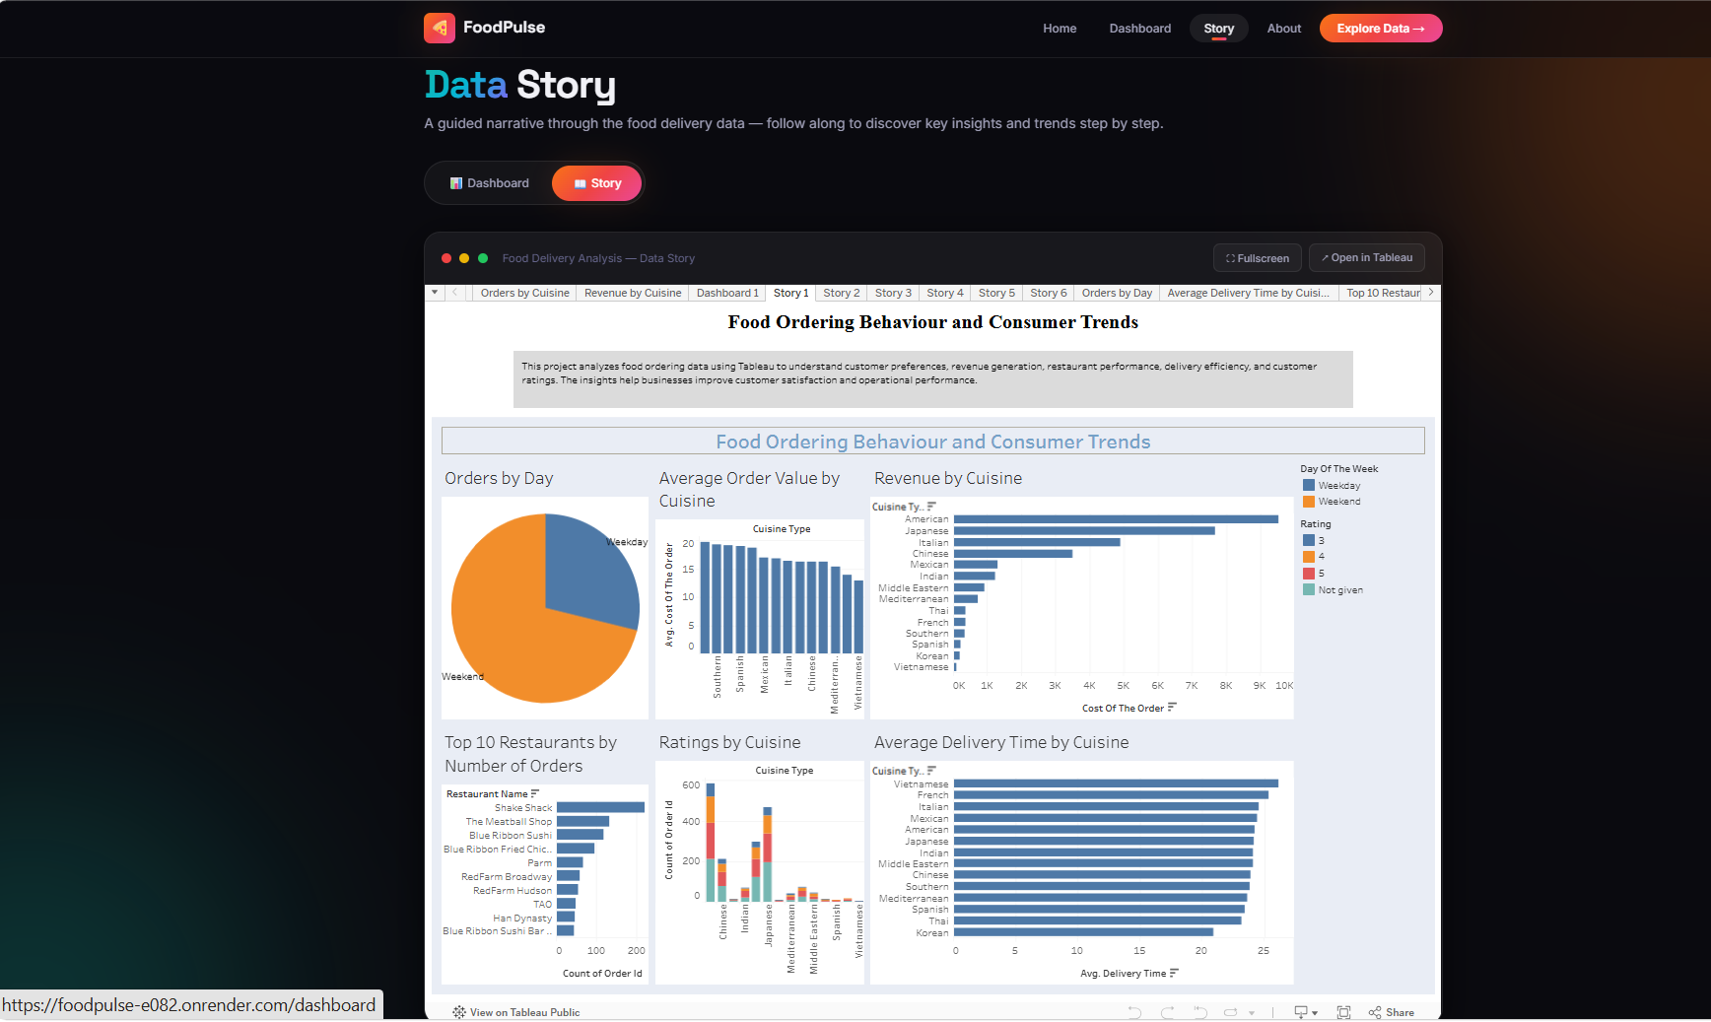
Module 6: Flask Web Application
The Tableau dashboards and stories are embedded into a Flask web application that provides navigation between different analytical pages.
Module 7: Cloud Deployment
The application is deployed on Render cloud hosting for public accessibility and scalability.
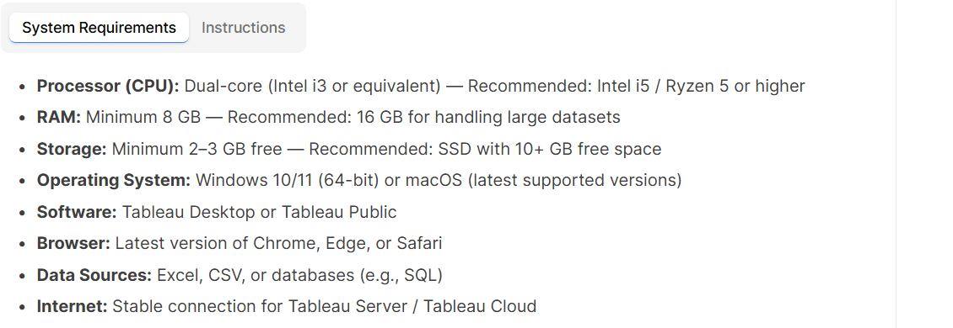

5. PROJECT PLANNING & SCHEDULING
Phase | Activity
Phase 1 | Requirement Analysis
Phase 2 | Dataset Collection
Phase 3 | Data Cleaning and Preparation
Phase 4 | Exploratory Data Analysis
Phase 5 | Dashboard Development
Phase 6 | Story Development
Phase 7 | Flask Web Application Development
Phase 8 | Cloud Deployment using Render
Phase 9 | Testing
Phase 10 | Final Documentation

6. FUNCTIONAL AND PERFORMANCE TESTING
Functional Testing
Test Case | Expected Result | Status
Open Home Page | Home page loads successfully | Passed
Open Dashboard | Dashboard displays correctly | Passed
Open Story Page | Story loads successfully | Passed
Navigate Between Pages | Navigation works properly | Passed
Open Embedded Tableau Reports | Reports display correctly | Passed
Invalid URL Request | Error page displayed | Passed
Performance Testing
- Web pages load within a few seconds.
- Embedded Tableau dashboards render efficiently.
- Flask application handles multiple requests effectively.
- Stable performance observed during repeated testing.
- Responsive performance across different devices and browsers.
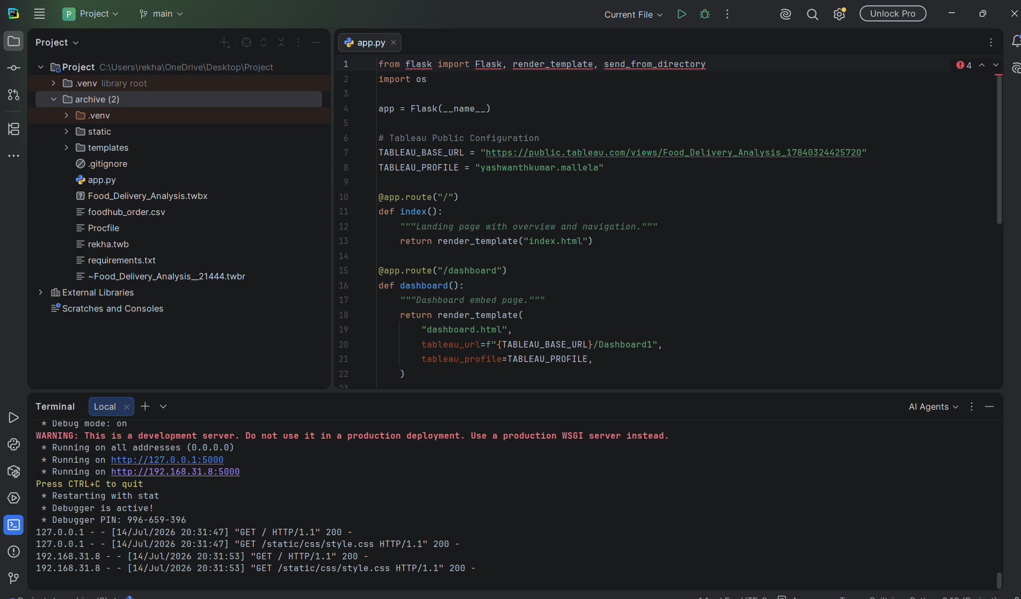

7. RESULTS
The project successfully analyzes food ordering behavior and consumer trends using data analytics and visualization techniques.
Major Achievements:
- Successful preprocessing of food ordering data.
- Identification of customer preferences and trends.
- Development of interactive Tableau dashboards.
- Creation of Tableau stories for business insights.
- Successful integration with Flask.
- Deployment on Render cloud platform.
- Public accessibility through a web application.
The application provides businesses with valuable insights that support strategic decision-making and operational improvements.
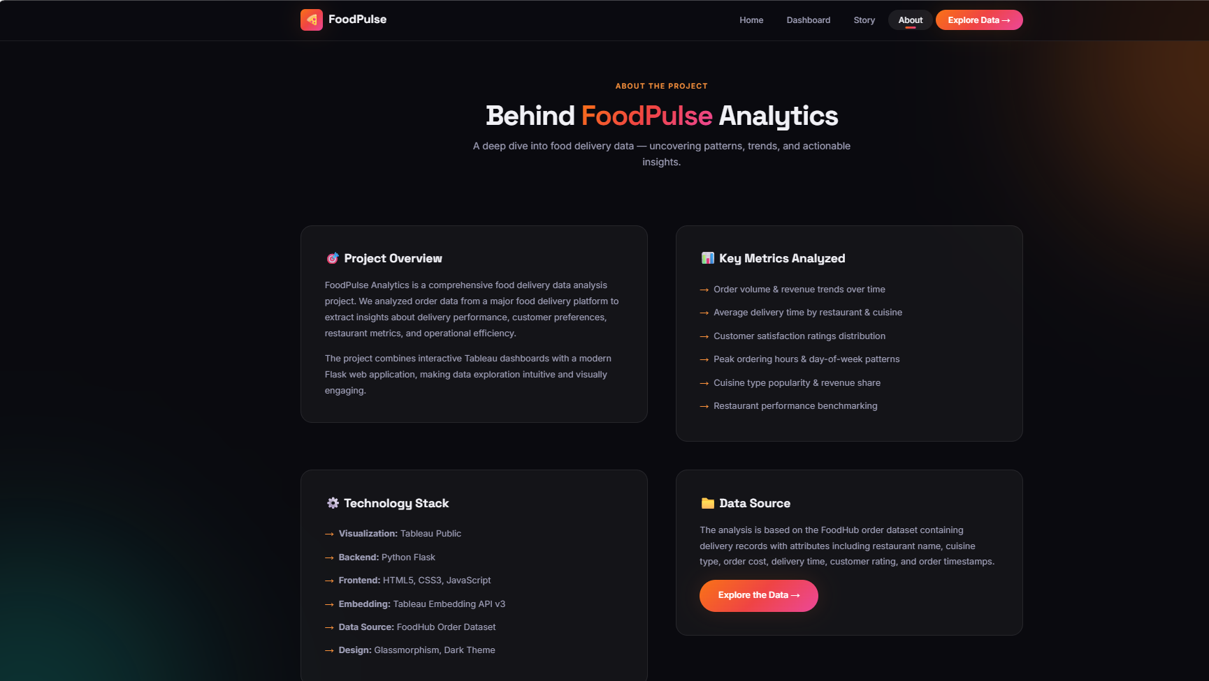

8. ADVANTAGES & DISADVANTAGES
Advantages
- Provides interactive business insights.
- Helps understand customer preferences.
- Supports data-driven decision making.
- Improves marketing strategy development.
- Enhances operational efficiency.
- User-friendly interface.
- Cloud accessibility.
- Scalable architecture.
Disadvantages
- Results depend on dataset quality.
- Historical data may not capture future trends.
- Requires periodic dashboard updates.
- Tableau embedding may increase loading time.
- Limited by available dataset features.

9. CONCLUSION
The project "Food Ordering Behaviour and Consumer Trends: A Structured Analysis of Choices and Habits" demonstrates the effective use of data analytics and visualization techniques for understanding customer behavior in food delivery services.
By integrating Tableau dashboards with a Flask web application, the system provides an interactive platform for analyzing customer preferences, ordering trends, and restaurant performance.
The project provides valuable learning experience in data analysis, Tableau dashboard development, Flask web development, and cloud deployment while addressing real-world business challenges in the food delivery industry.

10. FUTURE SCOPE
Future enhancements may include:
- Integration with live food delivery databases.
- Real-time analytics capabilities.
- AI-based recommendation systems.
- Customer segmentation using machine learning.
- Demand forecasting models.
- Mobile application development.
- Personalized customer recommendations.
- Integration with additional food delivery platforms.
- Predictive analytics for customer behavior.
- Advanced business intelligence reporting.

11. APPENDIX
Technologies Used
- Python
- Flask
- Tableau
- HTML
- CSS
- Bootstrap
- Render
- PyCharm
Dataset Used
- FoodHub Order Dataset
- Restaurant information
- Customer order details
- Cuisine details
- Delivery information
Visualizations Developed
- Customer ordering trends
- Popular cuisines analysis
- Restaurant performance dashboard
- Spending behavior analysis
- Delivery pattern visualization
Applications
- Food Delivery Platforms
- Restaurant Management
- Customer Behavior Analysis
- Marketing Analytics
- Business Intelligence
- Demand Forecasting
Project Links
Website:
FoodPulse Analytics — Food Delivery Insights

